Wakefield District Harriers & AC – Athletics Weekly Club Focus

Wakefield District Harriers & AC is a long established athletics club, which celebrated its centenary in 1995. The club caters for all branches of athletics, and all age groups, although in recent years they have had most success in track and field, particularly with their women’s team.

The ladies have been in one of the top two divisions of the UK Athletics league for the past 9 years now, 3 of them in the 1st Division, and they are the only Yorkshire club to have reached the highest level of club athletics. This is a remarkable achievement for a relatively small club, who receive no major sponsorship, and they were probably the only true amateur club to have managed this in recent years. They have also had success with their female distance runners, finishing in the top four in national road and cross-country relays.

The strength in track & field is helped by having excellent training facilities at Thornes Park Stadium, which has had an all weather track for around 15 years, and an excellent indoor training facility for over 10 years, These facilities were provided by Wakefield District Council after a lengthy campaign headed by long-time club president Doug Bedford.

It wasn’t always this way though, as the club was for many years predominantly a male harrier club, producing many fine distance runners over the years. These included international cross country runner Roland Walker in the 1930s, and in the 1970s there was marathon runner John Newsome running 2hrs 16, a time which today’s runners would struggle to achieve. John has been a loyal servant to the Harriers, and has been club chairman for the past few years. During this successful period two of the club’s greatest running talents emerged. The Hollings brothers achieved a rare family double in 1966, with Steve winning the English Schools senior steeplechase title, and Richard winning the intermediate mile. Richard was a prodigious talent, and as well as leading the U17 team to the National Cross-country title in 1967, in 1968 he won the English Schools senior 1500m in a CBP which lasted for many years. Whilst Richard never continued into the senior ranks Steve went on the represent Great Britain, and reached the steeplechase semi-final at the Munich Olympics of 1972.

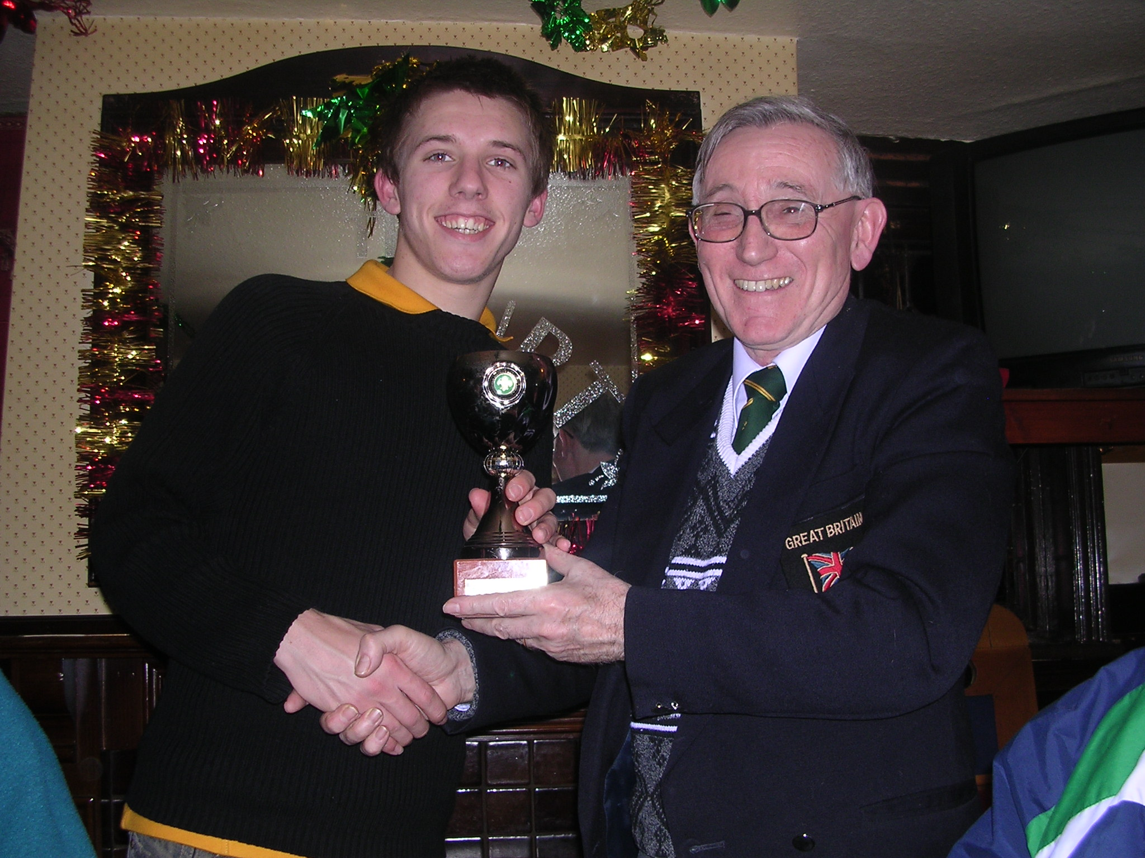
Club Chairman John Newsome with club cross-country champion Chris Price.

The club’s next Olympian was Alan Bell, who made the semi-final in the 400m at the 1980 Moscow games, and was followed four years later by Alan Slack in the 4x400m relay team at Los Angeles. Alan Slack was a phenomenal talent, who started out as a long jumper, breaking the UK age 17 record, before concentrating on sprinting and then the 400m. He later became a good road runner, and still occasionally turns out for the club in vets relay events. Has any other athlete ever run 10.7 for 100m, and also run 71 minutes for a half marathon ? With the Bell brothers, Alan Slack, Mike Harrison and some other talented athletes, the late seventies and early eighties were a strong period for the men’s team, winning the Northern League title in 1980, but not quite making it into the National League.

The women’s team really took off in the mid 1990s, with several multi-talented athletes including Kerry Jury and Maggie Still and an enthusiastic management team coming together. A bandwagon started to roll, and the team started climbing through the ranks from the Northern league and into the UK Women’s League, and with promotions every year they reached the 1st division in 1999. Of course success attracts other top talent, and many good athletes from the region have joined the club in recent years, including GB sprinter Emily Freeman, and last year’s top U20 hurdler Zara Hohn, who came 5th in the World Junior Championships.

However the club has a long tradition of producing it’s own international athletes, and GB cross country runner Aine Hoban and Britain’s top high jumper Martyn Bernard both started out as U11s with the club. The club were thrilled this winter when Aine came 4th in the European U23 Cross Country Championships, and Martyn won the Bronze medal at the recent European Indoor Championships. Wakefield Harriers have high hopes that from Martyn, Emily, Zara, Aine or 800m runner Charlene Snelgrove the club will have their next Olympian in 2008, to inspire the hoards of youngsters who come down to the club every Tuesday and Thursday.

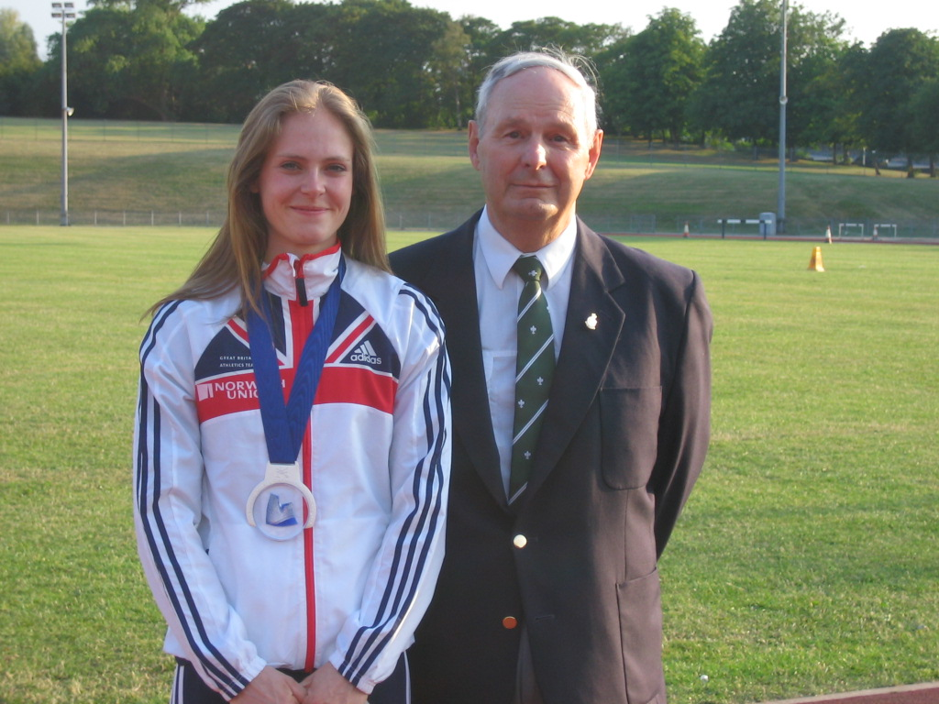
GB Sprinter Emily Freeman with proud Club President Douglas Bedford

The club has for a long time had a strong youth policy, and always turns out the greatest number of athletes in the West Yorkshire Track & Field League. They were one of the first clubs in the area to have an U11 section, and this has led to a steady stream of junior athletes coming through the ranks. In 2004 & 2005 the girl’s junior team finished in the top 6 in the National Junior League final, thus ensuring continuing success for the club in the next few years.

But Wakefield Harriers also recognise that not as many runners want to compete as competitively as in previous years, so now welcome the social runner into the club, as well as the more serious athletes. Whatever an athlete’s age or event, Wakefield Harriers will make them welcome, and provide assistance and coaching to help further their aims.

www.wakefield-harriers.co.uk

